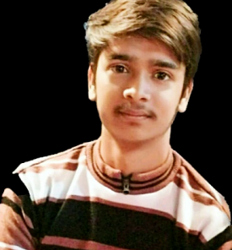New Delhi

INDIA

+91 8076321287

+91 9211404791

[shuklar727@gmail.com](mailto:shuklar727@gmail.com)

[www.hrishikesh.ml](http://www.hrishikesh.ml)

**HRISHIKESH A. SHUKLA**

**================================================================**

**SKILLS**

FLUENT LANGUAGES Hindi, English

PROGRAMMING LANGUAGES C, C++, Java, JavaScript, PHP, react native

WEB TECHNOLOGIES HTML5, CSS3, Bootstrap4, react.js, Sql, WordPress

DESIGNING SOFTWARES CorelDraw, Photoshop, Illustrator, InDesign

**EXPERIENCE**

As a freelancer I have worked and have been working with many clients. To name a few DK Explore world, Finesse Handcrafted, Grand Shell, Toolheads are the best clients to work with. My work for them was to composite and edit videos, design logos, flyers, business cards, etc. and website & android app development. I have 100+ happy clients.

My completed projects can be seen on my website.

**EDUCATIONAL QUALIFICATION**

* **B.C.A. (2017-2020)** From GGSIPU, New Delhi (INDIA)
* **Intermediate** from C.B.S.E. Board, New Delhi (INDIA)
* **High School** from C.B.S.E. Board, New Delhi (INDIA)

**PERSONAL DETAILS**

Date of Birth : 20.08.1999

Father’s name : Shri Sudhanshu S. Shukla

Marital Status : Single

Nationality : Indian

Languages known : English & Hindi

**DECLARATION**

I hereby declare that all the information given above is true to the best of my knowledge and belief.

**(Hrishikesh A. Shukla)**